**To set up:**

1. Log onto computer using HawkID and password
2. Turn on sound card. Blue light means it is on.
3. Go into booth and turn on ER10X. It will calibrate, then prompt you to disable the output limiter. Press the Enter button to disable.
4. Find the correct size probe tips and put them on.
5. If testing yourself, turn on the monitor in the booth.
6. Go back to computer. There may be a window that pops up that says “Mismatch Detected”. Click No.
7. A screenshot of a computer

   Description automatically generatedOpen TotalMix.
8. Click File, Load Workspace, fireFaceSettings.tmws. Then click Function, Matrix. It should look like this.

1. Open MATLAB by clicking the icon on the desktop.
2. Make sure your path is set up to be C: > MyWork > ARLas.
3. In the Command Window, type s and hit enter to set up the path.

**To change parameters:**

1. In the Current Folder, find the code you want to load. For example, I am opening Peripheral > experiments > ARL > DPOAE, then selecting the program I want to load.

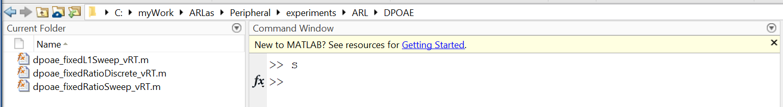

1. A screenshot of a computer

   Description automatically generated This will open up the Editor Window. Here is where you can change the parameters of the program, if needed. For example, here I can change my frequency (f2) or level (targetL2). After changing your parameters, make sure to click Save.
2. Then you can close the Editor Window.

**To run a program:**

1. In the Command Window, type arlas;
2. This window will pop up. If you followed the instructions in step 3 to disable the output limiter on the ER10X, then click OK.
3. Click Initialize. Open ARL_initialization. If it doesn’t come up automatically, you can find it in C: > MyWork > ARLas > Peripheral > sysConfigs.
4. Click Load. Find the program you want to run, probably the one you just changed the parameters of.
5. Click Run. A window will pop up for you to enter the Subject ID, Experiment ID, and Operator Initials. Once you have entered this information, click Enter ID. Then click Run.
6. Your test will run.
7. If at any point during the test you want to stop the program, click Abort.

**To close:**

1. When you are done running tests, click the ‘X’ to close the ARLas window.
2. In the Command Window, type exit.
3. Go in the booth and turn off the ER10X. Remove the probe tips and put them in the dirty tip bin.
4. If the monitor in the booth is on, turn it off.
5. Turn off the sound card.
6. Log out and shut down computer.